Pitt tonight 2020-2021 Marketing department application

Name:

Pronouns:

Year/Major(s), Minor(s), Certificate(s):

Phone number:

Email address (the one you check the most):

- Why do you want to work with Pitt Tonight? Do you have any related experience to television production or work with the entertainment industry?

- Why Marketing?

- What other involvement do you have on campus (organizations, jobs, etc.)? How many hours a week can you dedicate to the show?

- If Pitt Tonight had unlimited resources, what marketing campaign would you create to generate more awareness of Pitt Tonight OR what guests you would bring to the show?

- If you have any experience with any editing software/programs (ex: Adobe Photoshop, Illustrator, InDesign, Premiere etc.), please elaborate below:

- Which area(s) of marketing interest you the most? Please highlight your general areas of interest.

  - Social Media
  - YouTube/Video Content
  - Graphic Design
  - Event/Fundraiser Planning
  - Talent (Finding guests for our show!)

- Would you be at all interested in any of these more specialized positions which we have in our department (highlight if yes)?

  - Business Manager - works with the UPTV business manager for Pitt Tonight finances
  - Partnership Manager - contacts other organizations for collaborations (for example, cross-promoting Pitt clubs on the Pitt Tonight platform)
  - Social Media Managers - manages posts and writes copy on Facebook, Instagram, Twitter, TikTok, and YouTube
  - Website Manager - updates the website weekly with applications, episodes, and other Pitt Tonight content
  - Newsletter Manager - keep people updated with Pitt-Tonight events and episodes (which is so important for this semester)
  - Graphic Designer - help to brainstorm and execute graphics needed to promote the show; graphics include but are not limited to flyers, Instagram story content, tickets (when we hold in-person shows), and guest announcements
  - I just want to chill and get a taste of the group!

- Please answer at least one of the following creative prompts:

  - Caption this photo for Instagram! (Context: Our host Victoria sitting next to a stuffed animal “audience” dressed in Pitt Tonight shirts for the Season 6 Premiere)
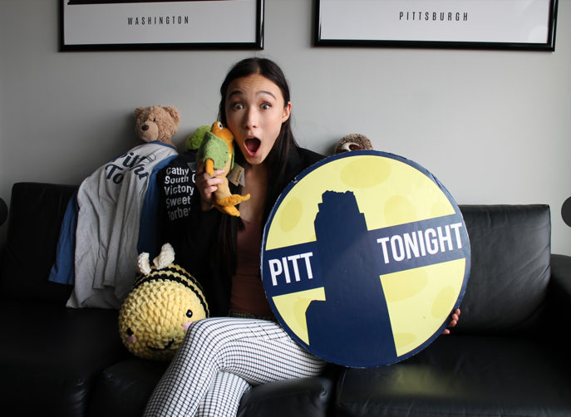

  - Show us your graphic design skills! Create a new logo for Pitt Tonight or anything else Pitt Tonight-related (flyer, ticket, mock guest announcement post, etc.)
  - Pitch us a creative fundraising idea. What resources would this require? How would it engage the student population?
  - Find a guest for Pitt Tonight and write down questions you would ask them for an interview.

- Finally, How did you first hear about Pitt Tonight and our application?

